# System Architecture

Contents

System Architecture 1

Introduction 1

Key Components 1

User Types and Transitions 1

Interaction Flow 2

Conclusion 3

## Introduction

This document describes the architecture of a multi-tenant system designed to provide a set of configurable services to partner users. The services are tailored for each partner, allowing them to customize system functionalities and permissions. The system supports several user types with specific limitations and capabilities.

## Key Components

The architecture consists of several key components.

1**. Partner Management Module**: Allows partners to configure functionalities and permissions for their users.

2. **User Management Module**: Handles user registration, authentication, and transitions between user types.

3. **Session Management Service**: Manages user sessions, including time tracking and operation counting for guest and basic users.

4. **Operation Tracking Service**: Allows to configure permissions for different user types ("basic", "guest", "company", "advanced") and monitors the number of operations performed by users based on their type.

5. **KYC Service**: Facilitates the Know Your Customer (KYC) process, which allows "guest" users to upgrade to "basic" status.

## User Types and Transitions

The system supports four types of end-users, each with specific allowed transitions.

|  |  |  |  |  |
| --- | --- | --- | --- | --- |
| User Type | Daily Operations Limit | Weekly Operations Limit | Session Time Limit | Possible Transitions |
| Guest | 5 | 20 | 20 minutes | guest → basic → advanced |
| Basic | 20 | 50 | Unlimited | advanced → basic → guest |
| Advanced | Unlimited | Unlimited | Unlimited | advanced ↔ company |
| Company | Unlimited | Unlimited | Unlimited | company ↔ advanced |

The diagram below illustrates the state transitions.

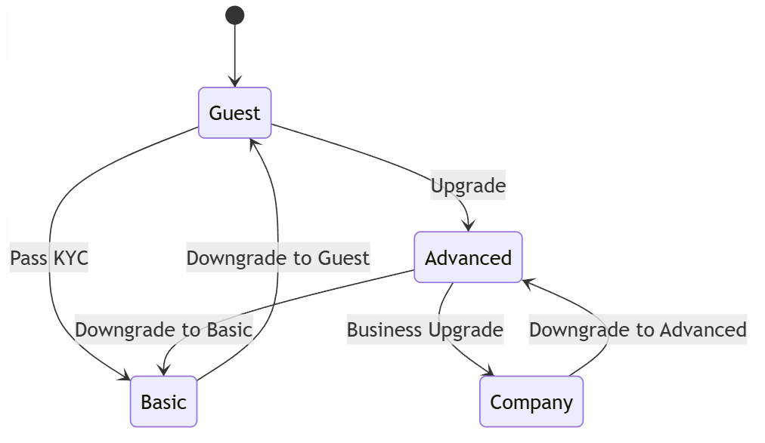

Figure 1: State transitions

## Interaction Flow

The system supports the following scenarios.

1. User Registration and Login

- New users register through the User Management Module. Guest sessions are initiated with limited functionality.

2. Session Monitoring

- The Session Management Service monitors active sessions, enforcing time and operation limits for guest and basic users.

3. User Status Transition

- Users undergo transitions based on their activity and completed KYC processes, handled by the Operation Tracking Service.

4. Partner-Specific Configuration

- Each partner is configured through the Partner Management Module to enable specific functionalities and set permissions.

## Conclusion

This system is designed to provide a flexible and scalable solution for managing multiple partners and user types. It ensures each partner can customize service offerings while maintaining control over user activities and transitions.